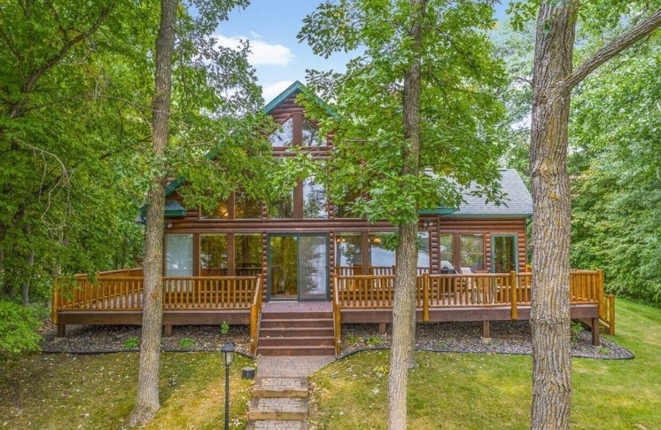 $2,750
https://www.vrbo.com/2095951?chkin=2026-06-06&chkout=2026-06-13&d1=2026-06-06&d2=2026-06-13&startDate=2026-06-06&endDate=2026-06-13&x_pwa=1&rfrr=HSR&pwa_ts=1774949521935&referrerUrl=aHR0cHM6Ly93d3cudnJiby5jb20vSG90ZWwtU2VhcmNo&useRewards=true&adults=4&regionId=553248635976431909&destination=Crow%20Wing%20County%2C%20Minnesota%2C%20United%20States%20of%20America&destType=BOUNDING_BOX&latLong=46.358022%2C-94.200829&searchId=bde76380-a2f1-429e-b06d-35191af2e737&sort=RECOMMENDED&top_dp=367&top_cur=USD&userIntent=&selectedRoomType=59618906&selectedRatePlan=0004462bd46c23e048439fb012ecc799fb7a&expediaPropertyId=59618906&pwaThumbnailDialog=thumbnail-gallery
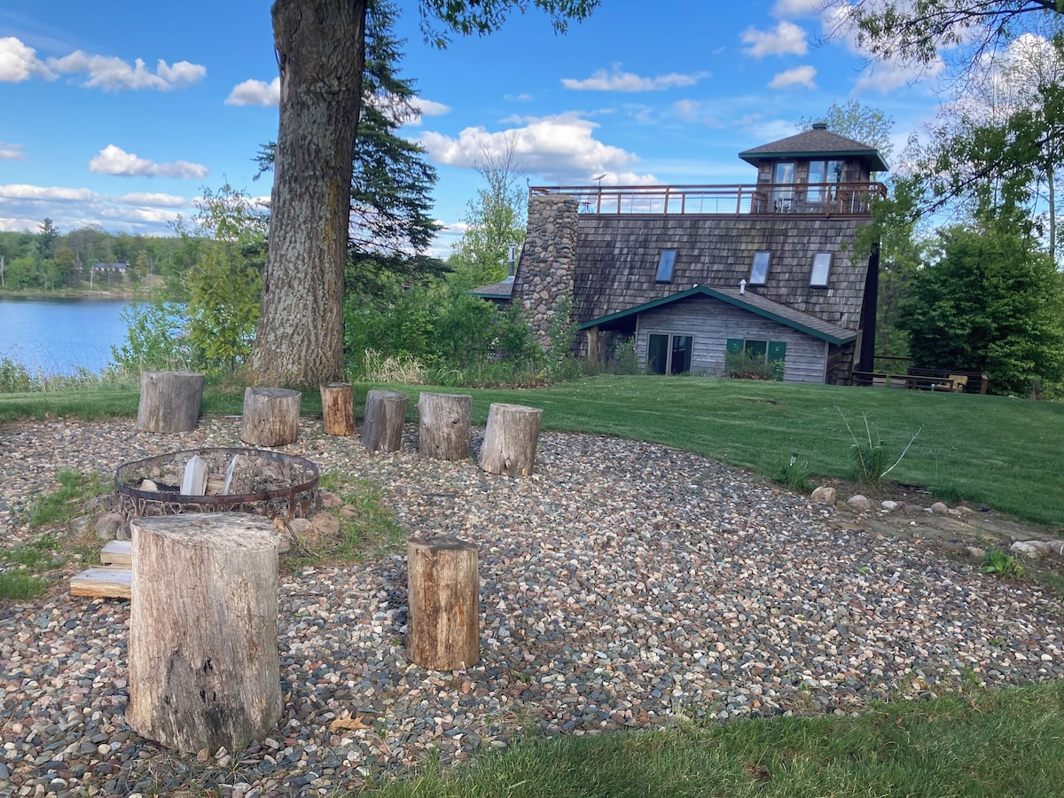 $2475

https://www.vrbo.com/1327265?chkin=2026-06-06&chkout=2026-06-13&d1=2026-06-06&d2=2026-06-13&startDate=2026-06-06&endDate=2026-06-13&x_pwa=1&rfrr=HSR&pwa_ts=1774949522017&referrerUrl=aHR0cHM6Ly93d3cudnJiby5jb20vSG90ZWwtU2VhcmNo&useRewards=true&adults=4&regionId=553248635976431909&destination=Crow+Wing+County%2C+Minnesota%2C+United+States+of+America&destType=BOUNDING_BOX&latLong=46.358022%2C-94.200829&searchId=bde76380-a2f1-429e-b06d-35191af2e737&sort=RECOMMENDED&top_dp=345&top_cur=USD&userIntent=&selectedRoomType=27130220&selectedRatePlan=00045e1fb6616c7048e789746bc4e5ccc277&expediaPropertyId=27130220

